**Name: Deepankar Sharma course: BCA-6th roll no: 2092014**

**Subject: Computer Graphics**

|  |  |  |  |
| --- | --- | --- | --- |
| **Index** | | | |
| **S. No.** | **Objective** | **Date** | **Signature** |
| 1 |  |  |  |
| 2 |  |  |  |
| 3 |  |  |  |
| 4 |  |  |  |
| 5 |  |  |  |
| 6 |  |  |  |
| 7 |  |  |  |
| 8 |  |  |  |
| 9 |  |  |  |
| 10 |  |  |  |
| 11 |  |  |  |
| 12 |  |  |  |
| 13 |  |  |  |

NAME- Deepankar Sharma

COURSE- BCA

ROLL NO- 2092014

SUBJECT- Computer graphics lab

PRACTICLE-1

OBJECTIVE- DRAW A SMILEY FACE THOUGH GRAPHICS

SYNTAX :-

#include <graphics.h>

int main()

{

int gr = DETECT, gm;

initgraph(&gr, &gm, "C:\\Turboc3\\BGI");

setcolor(YELLOW);

circle(300, 100, 40);

setfillstyle(SOLID_FILL, YELLOW);

floodfill(300, 100, YELLOW);

setcolor(BLACK);

setfillstyle(SOLID_FILL, BLACK);

fillellipse(310, 85, 2, 6);

fillellipse(290, 85, 2, 6);

ellipse(300, 100, 205, 335, 20, 9);

ellipse(300, 100, 205, 335, 20, 10);

ellipse(300, 100, 205, 335, 20, 11);

getch();

closegraph();

return 0;

}}

OUTPUT:

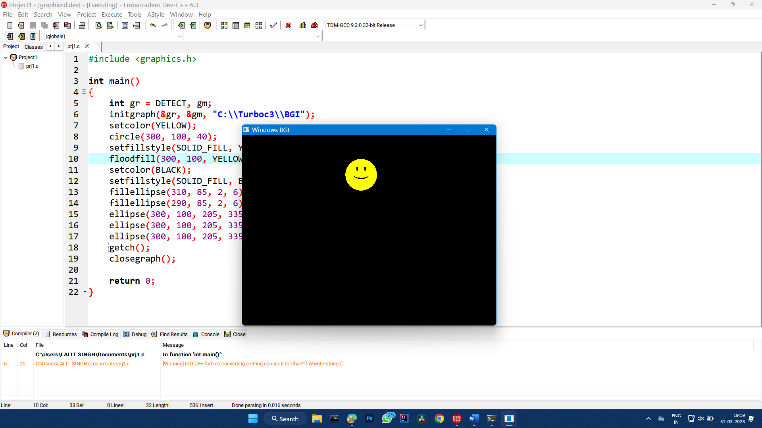

NAME- Deepankar Sharma

COURSE- BCA

ROLL NO- 2092014

SUBJECT- Computer graphics lab

PRACTICLE-2

OBJECTIVE- To divide your screen into four region, draw circle, rectangle, ellipse ,square.

SYNTAX :-

#include<conio.h>

#include<graphics.h>

#include<stdio.h>

int main()

{

int gdriver = DETECT, gmode;

int xmax,ymax;

initgraph(&gdriver, &gmode,"c:\\turboc3\\bgi");

xmax = getmaxx();

ymax = getmaxy();

line(xmax/2,0,xmax/2,ymax);

line(0,ymax/2,xmax,ymax/2);

outtextxy (xmax/2,ymax/2,"(0,0)");

setcolor(GREEN);

setfillstyle(HATCH_FILL,RED);

circle(170,125,100);

outtextxy (160,135,"circle");

floodfill(170,125,GREEN);

setcolor(YELLOW);

setfillstyle(2,RED);

rectangle(58,251,304,392);

outtextxy (70,300,"Rectangle");

floodfill(70,351,YELLOW);

setcolor(BLUE);

setfillstyle(3,RED);

rectangle(400,50,500,150);

outtextxy (450,70,"square");

floodfill(450,80,BLUE);

setcolor(RED);

setfillstyle(4,RED);

ellipse(500,300,0,360,75,25);

outtextxy (500,300,"ellipse");

floodfill(500,300,RED);

getch();

closegraph();

return 0;

}

OUTPUT:

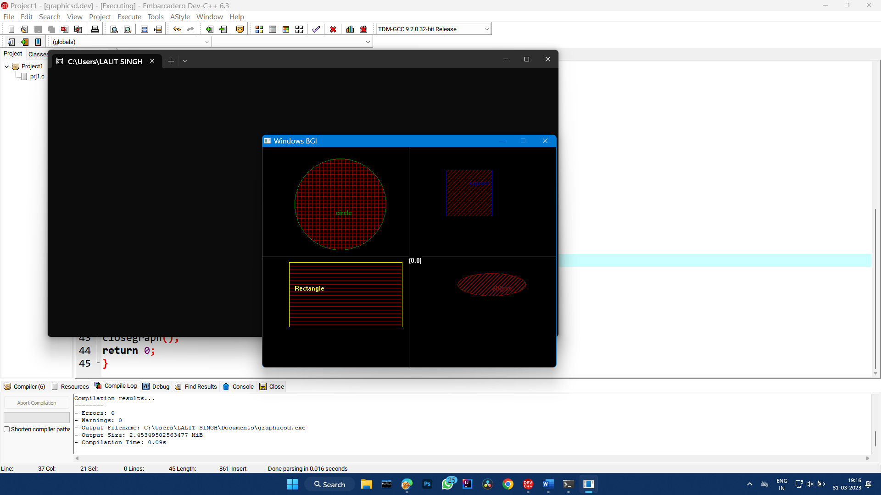

NAME- Deepankar Sharma

COURSE- BCA

ROLL NO- 2092014

SUBJECT- Computer graphics lab

PRACTICLE- 3

OBJECTIVE- DRAW A HOUSE THOUGH GRAPHICS

SYNTAX :-

#include <graphics.h>

int main() {

int gd = DETECT, gm;

initgraph(&gd, &gm, "");

rectangle(100, 200, 300, 400);

line(100, 200, 200, 100);

line(200, 100, 300, 200);

rectangle(120, 220, 180, 280);

rectangle(220, 220, 280, 280);

rectangle(160, 320, 240, 400);

getch();

closegraph();

return 0;

}

OUTPUT:

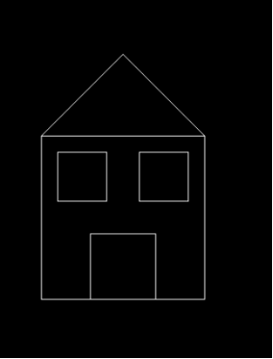

NAME- Deepankar Sharma

COURSE- BCA

ROLL NO- 2092014

SUBJECT- Computer graphics lab

PRACTICLE-4

OBJECTIVE- TO IMPLEMENT THE DDA LINE GENERATION ALGORITHM THOUGH GRAPHICS

SYNTAX :-

#include<graphics.h>

#include<conio.h>

#include<stdio.h>

int main()

{

int gd = DETECT ,gm, i;

float x, y,dx,dy,steps;

int x0, x1, y0, y1;

initgraph(&gd, &gm, "C:\\TC\\BGI");

x0 = 200 , y0 = 300, x1 = 500, y1 = 100;

dx = (float)(x1 - x0);

dy = (float)(y1 - y0);

if(dx>=dy)

{

steps = dx;

}

else

{

steps = dy;

}

dx = dx/steps;

dy = dy/steps;

x = x0;

y = y0;

i = 1;

while(i<= steps)

{

putpixel(x, y, WHITE);

x += dx;

y += dy;

i=i+1;

}

getch();

closegraph();

}

OUTPUT:

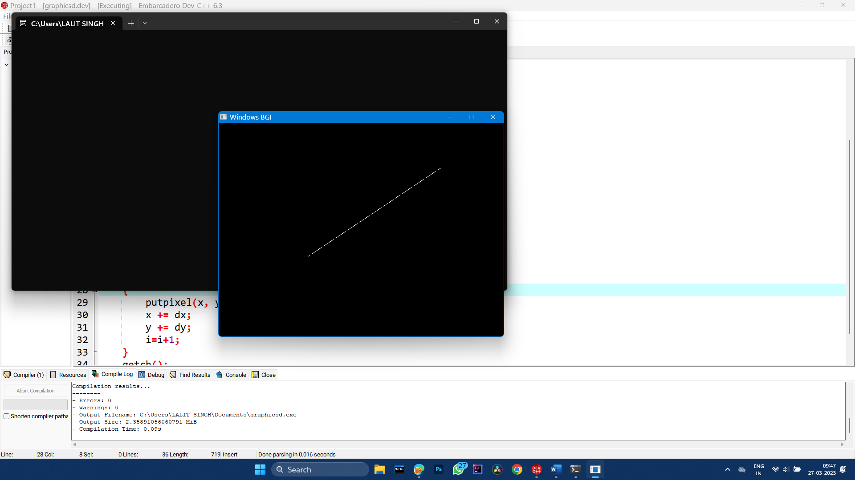

NAME- Deepankar Sharma

COURSE- BCA

ROLL NO- 2092014

SUBJECT- Computer graphics lab

PRACTICLE-5

OBJECTIVE- TO IMPLEMENT THE Bresenham's Line Algorithm THOUGH GRAPHICS

SYNTAX :-

#include <iostream>

#include <graphics.h>

void bresenham(int x1, int y1, int x2, int y2) {

int dx = x2 - x1;

int dy = y2 - y1;

int p = 2 * dy - dx;

int twoDy = 2 * dy;

int twoDyMinusDx = 2 * (dy - dx);

int x = x1;

int y = y1;

if (x1 > x2) {

x = x2;

y = y2;

x2 = x1;

} else {

x = x1;

y = y1;

}

putpixel(x, y, WHITE);

while (x < x2) {

x++;

if (p < 0) {

p += twoDy;

} else {

y++;

p += twoDyMinusDx;

}

putpixel(x, y, BLUE);

}

}

int main() {

int gd = DETECT, gm;

initgraph(&gd, &gm, "");

bresenham(100, 100, 300, 200);

getch();

closegraph();

}

OUTPUT:

